EHCP Preparing for Adulthood Annual Review
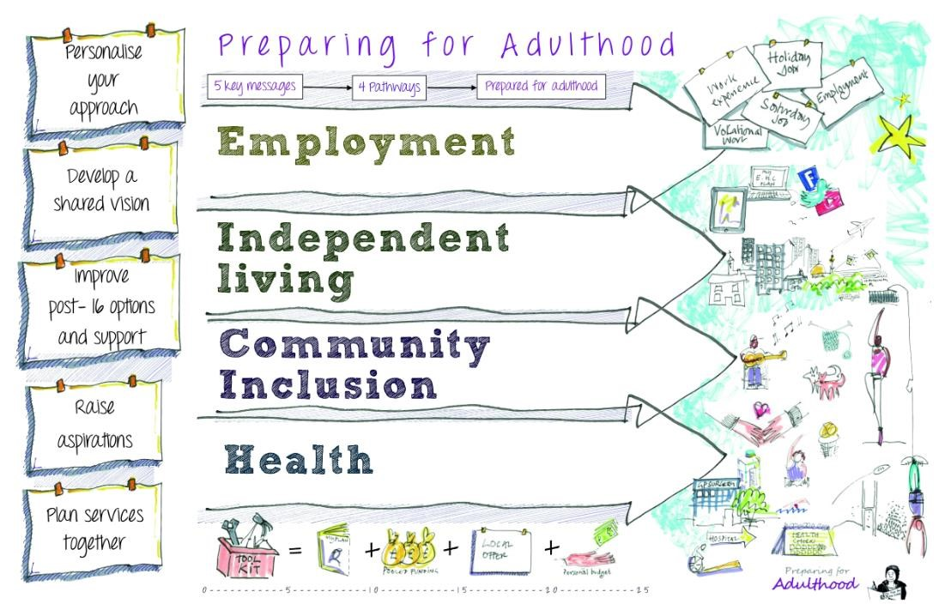
(from Year 9)

Name: ………………………………………………………
Setting: …………………………………………………….
Date of Annual Review: ……………………………….

Person-centred Planning
Barking and Dagenham Education, Health and Care plans need to be holistic, outcomes focussed, person centred and aspirational. They must reflect the gifts and talents of our young people. It is vital that young people are supported to contribute to their annual review and share their views. This could be in person at the meeting, through a written statement, a conversation with a trusted family member or staff, choosing visuals or whatever manner of communication the young person prefers.
Person centred planning is NOT solely the ‘all about me’ booklet. It should be the centre of EHCP planning and review.
Key information to include
Alongside the annual review document, any of the following should be submitted:
- Parent/carer views
- Vocational profile (Year 11)
- Communication passport
- Teacher/tutor reports
- Careers interview summary (Year 11)
- Any other relevant information
Content
- Contributors
- My details
- My achievements & my journey
- What matters
- My outcomes
- Communication passport
- Decision making profile
- What’s working and what’s not working
- Coping strategies
- 7 key questions

We express our great thanks to the National Development Team for Inclusion (NDTI) for their invaluable support and knowledge sharing. Before using person centred planning materials, please read this introduction as well as the guidance provided with each tool.
Name | Role | Invited | Attended | Report attached

- Names and roles of those contributing to the Annual Review

- My Details
Family name |  | First name |  | Preferred name
Date of birth |  | Gender |  | Year group
Home address |  |  |  | Preferred Language
Parent’s / Carer’s names |  | Contact details
CLA / CP / CIN? |  | Social Worker contact
Date of first issue of EHC Plan |  | Date of previous review |  | Funding Profile
Name of Education Setting |  |  |  | Attendance %  (report attached)
Main area of need (select one only) | Cognition & Learning | Communication and Interaction | Social Emotional and Mental Health | Physical and/or Sensory Needs | Medical Needs

My Achievements & My Journey
Congratulations!
(My photos, interests, activities, pieces of work, certificates)

3. What Matters
- NDTi Guidance link - This template is designed to help young people talk with their family, carers and any paid supporters to coproduce a summary Preparing for Adulthood plan.
- Relevant EHCP Section: A
What I want in the future:
What people like about me:
What I’m good at:
Things I need support with/what is important for me:
What matters – People, things to do, things to have:
What I enjoy:

4. My Outcomes
- NDTi Guidance link - Using My Outcomes is part of an approach that enables us to genuinely find out what is important to a young person now and for their future.
- Relevant EHCP Section: E
Employment
Friends, Relationship and Community
Independent Living
Good Health (and wellbeing)

5. Communication Passport
- NDTi Guidance link - This is a helpful tool and is essential to use when people don’t use many words to speak.
- Relevant EHCP Section: A, B
At this time:
I do this:
It means:
You need to:

6. Decision Making Profile
- NDTi Guidance link - The decision-making profile creates a clear picture about how a person makes a decision and how they want to be supported in decision-making.
- Relevant EHCP Section: A, B
How I like to get information:
How to present choice to me:
Ways you can help me understand:
The best time for me to make decisions:
The worst time for me to make decisions:

7. What’s working and What’s not working
- NDTi Guidance link - This tool helps people to sort out what is working and what is not working from different perspectives and to work out ways to build on what is working and to reduce or stop the things that aren’t working.
- Relevant EHCP Section: B C, D, F, G, H
What’s working:
What are you going to keep, develop or grow:
What’s not working:
What are you going to change or let go of:

8. Coping Strategies
• NDTi Guidance link - A person-centred planning tool to help children & young people to express their anxieties and concerns. • Relevant EHCP Section: B, C, D, F, G, H
Things happening in the near future:
What can I do to feel better about my worries:
What can others do to help:

7 Key Questions

- Have there been any significant changes in circumstances in the past year?
Change in learning need, family circumstances etc.


2. A brief update on my strengths and special educational needs (please attach reports if significant new needs were identified/diagnoses made).
Cognition & Learning:

Communication & Interaction:

Social, Emotional & Mental Health:

Independence:

2. Continued


3. A brief update on my health and care needs (please attach reports if significant new needs were identified/diagnoses made).

4. What progress has been made towards achieving the outcomes in my EHCP? Are any new or amended outcomes required?




5. Summary of meeting

6. Recommendation to the Local Authority
Please tick one only:
- Continue to maintain the EHCP without amendments
- Amend the EHCP based on the evidence provided
- Cease to maintain the EHCP
- Re-assessment of EHC needs
Is a change of placement recommended? Please attach detailed report outlining reasons.



7. Transfer between phases
For children in Years 9 to 11
- Have parents/carers or the child expressed any preference for the next phase of education?

- What are the school’s views for the next phase?

For young people in Year 12 and above
- Has the young person (or parent carer if MCA applies) expressed any preference for the next phase of their education (such as leaving education or continuing in a different setting)?

- What are the school/college’s views for the next phase?

- Is this young person expected to need support from adult social care?

